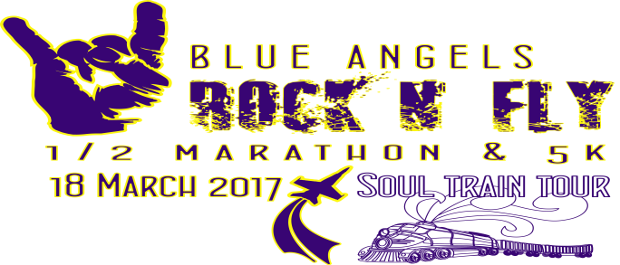

Why should you be a sponsor for the Rock N Fly?
Here are the reasons:
Take 1 - It supports the Navy Marine Corps Relief Society.
Take 2 - It is a fund raiser for the Navy Ball.
Take 3 - You will be part of one of the largest running events in the region. It is the only half marathon held on NAS Pensacola. We put on one of the most exciting road racing events in the country and have between 2500- 3,000 participants.
SPONSORSHIP OPPORTUNITIES
Rock N Fly Crew $250.00
2 complimentary race entries, logo on website, classic poster, and logo on race shirts.
Rock N Fly Rocker $500.00
5 complimentary race entries, logo on website, classic poster, logo on race shirts, and advertisement at packet pick up.
Rock N Fly Rock Star $1000.00
10 complimentary race entries, logo on website, classic poster, logo on race shirts, announcement at race on jumbo- tron and at least 3 times from announcer, and advertisement at packet pick up.
Rock N Fly Rock Star Platinum $2500.00
20 complimentary race entries, logo on website, classic poster, logo on race shirts, announcement at race on jumbotron, and at least 5 times from announcer, advertisement at packet pick up, and logo will be printed on results.
We must have your logo and application prior to February 24, 2017 to be on t- shirts.
Please mail all sponsorship applications to the below address. Check should be made payable to Navy Ball Association. Please mail to: Please enter sponsor information below:
Navy Ball Association Company name or individual_______________________________
320 Gamarra Rd Address________________________________________________
Pensacola, FL. 32503 Contact #_______________________________________________
For the logo you would like to be used on the t-shirts and banners please send attachment to runrocknfly@gmail.com or contact Timothy Drill at 419-371-8762 or timothy.s.drill.mil@mail.mil
Please if you have any questions go to the website at www.runrocknfly.com or call 301-788-9721. We are grateful for any sponsorship and support.

